ORTHOPAEDIC INSTRUMENTS
Instruments for Intramedullary Nails
Bone Awl for Large Bones
Intended Use
The large-bone bone awl is a heavy-duty cortical penetrating instrument used in veterinary orthopaedic surgery to create the medullary entry portal for intramedullary nail insertion into the femur, tibia and humerus of large and giant-breed dogs. Its robust tip handles the dense cortical bone of large patients during fracture fixation. | 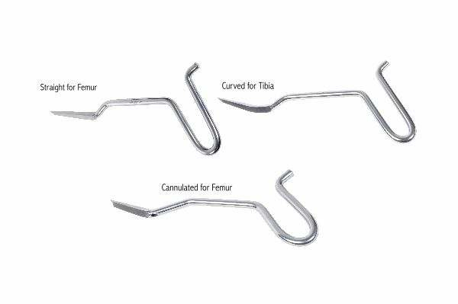
Function
The heavy-gauge hardened steel tip is driven through the metaphyseal cortex by manual rotational pressure combined with firm axial force, or by controlled mallet tapping on the T-handle. The large-diameter tip creates an entry portal matching the outer diameter of large intramedullary nails (4.0–8.0 mm), allowing the nail to enter the medullary canal without requiring a separate drill step.
Advantages
Single-Step Portal Creation for Large Nails: The oversized tip creates an entry portal diameter sufficient for large intramedullary nails in a single step, eliminating sequential pilot drilling and portal dilation steps that increase surgical time and thermal bone damage in large patients.
Robust Construction for Dense Large-Breed Cortex: Heavy-gauge hardened steel tip and shaft construction withstands the higher axial forces required to penetrate the thick cortical walls of large-breed dog long bones without tip deflection or handle breakage.
FAQ
Q: What nail diameters require the large-bone awl rather than the standard bone awl?
A: The large-bone awl is used for nail diameters of 4.0 mm and above, typically for intramedullary nailing of femur and tibia fractures in medium to giant-breed dogs weighing 25 kg or more.
Q: Can the large-bone awl be used in equine orthopaedics?
A: In equine surgery, power-drilled pilot holes are generally preferred over hand awls for cortical entry due to the extreme cortical thickness; however, large-bone awls are used in foal fracture cases.

ORTHOPAEDIC INSTRUMENTS
Instruments for Intramedullary Nails
Bone Awl for Radius-Ulna
Intended Use
The radius-ulna bone awl is a slender, anatomy-specific cortical penetrating instrument used in veterinary orthopaedic surgery to create the intramedullary entry portal in the radius and ulna of dogs and cats. Its slim profile is designed for the narrow metaphyses of the antebrachial bones during intramedullary fracture fixation. | 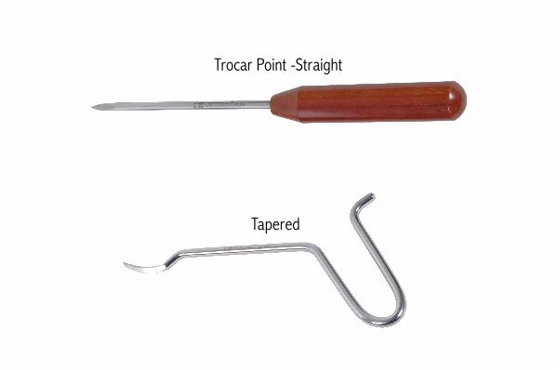
Function
The fine-gauge hardened tip is precisely sized for the thin cortical walls and narrow medullary canals of the radius and ulna. Gentle rotational pressure with minimal axial force penetrates the proximal or distal radial and ulnar cortex without cortical crack propagation. The slim handle allows controlled tactile feedback essential for avoiding epiphyseal and physeal injury in young patients.
Advantages
Anatomy-Matched Slim Profile Prevents Cortical Fracture: The reduced-diameter tip matches the thin radial and ulnar cortex thickness, preventing the cortical cracking and splitting that would result from using an oversized awl on the small-diameter antebrachial bones of dogs and cats.
Precise Tactile Feedback During Penetration: The slender shaft transmits direct tactile sensation of cortical penetration to the surgeon's hand, providing immediate feedback when the tip enters the medullary canal and preventing inadvertent far-cortex penetration.
FAQ
Q: Which end of the radius is used as the entry site for intramedullary nailing?
A: For antebrachial intramedullary nailing in dogs, the proximal radius is the most common entry site for antegrade nailing; the distal radius may be used retrograde in specific fracture configurations.
Q: Is this awl used in cats as well as dogs?
A: Yes. A fine-gauge variant is available for feline radius-ulna nailing, sized for the particularly narrow medullary canals of cats where even a slender canine awl would be oversized.

ORTHOPAEDIC INSTRUMENTS
Instruments for Intramedullary Nails
Bone Awl with Eye
Intended Use
The bone awl with eye is a dual-function instrument used in veterinary orthopaedic surgery to create a cortical entry portal and simultaneously pass a guide wire or suture through the medullary canal during intramedullary nail insertion in dogs and cats. The eye at the tip carries the guide element through bone during initial canal access. | 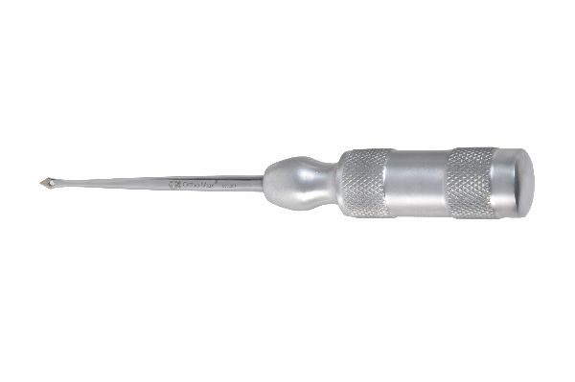
Function
The awl tip penetrates the cortex in the same manner as a standard bone awl. The eye — a small hole through the tip perpendicular or parallel to the shaft — accepts a wire or suture before insertion. As the awl penetrates the cortex, it carries the wire through the cortical channel, leaving the guide wire in position when the awl is withdrawn. The wire then guides the nail into the medullary canal.
Advantages
Simultaneous Portal Creation and Guide Wire Placement: The eye allows portal creation and guide wire introduction in a single insertion, eliminating the separate guide wire threading step and reducing the number of instrument insertions into the medullary canal during nail fixation.
Accurate Guide Wire Trajectory from First Pass: Guide wire placement through the awl eye follows exactly the trajectory of the awl tip, ensuring the wire is in the optimal medullary position from the outset rather than requiring repositioning after independent wire insertion.
FAQ
Q: What guide wire diameter passes through the bone awl eye?
A: The eye is typically sized for 0.9–1.2 mm guide wires or sutures, accommodating the wire sizes used for nail guidance in small to medium-breed dog and feline intramedullary nail procedures.
Q: Is the bone awl with eye used for over-the-wire nail insertion techniques?
A: Yes. The guide wire passed through the awl eye is retained in the medullary canal and the intramedullary nail or cannulated nail is threaded over the wire for guided insertion into the canal.

ORTHOPAEDIC INSTRUMENTS
Instruments for Intramedullary Nails
Cobbler Awl
Intended Use
The cobbler awl is a curved-tip cortical penetrating instrument used in veterinary orthopaedic surgery to create the medullary entry portal for intramedullary nail insertion at oblique or acute approach angles in long bones of dogs and cats. Its angled tip enables entry sites on curved bone surfaces where straight awls cannot be applied perpendicular to the cortex. | 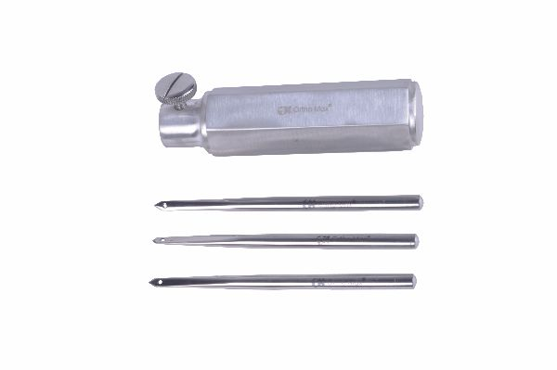
Function
The curved or angled tip geometry allows the awl to approach the bone at an acute angle and still penetrate the cortex in the direction of the medullary canal axis. This is particularly useful when the entry portal must be placed on a curved metaphyseal surface, near a bony prominence, or in confined anatomical spaces where a straight awl would require an excessively steep insertion angle.
Advantages
Oblique Cortical Access at Acute Angles: The curved tip geometry allows the awl to penetrate cortex at approach angles unsuitable for straight instruments, enabling medullary entry on curved bone surfaces and in confined anatomical corridors without compromising portal alignment with the canal.
Reduced Periosteal Stripping at Entry Site: The curved tip follows the bone surface contour more closely than a straight instrument during initial placement, reducing inadvertent periosteal elevation around the planned entry site before penetration begins.
FAQ
Q: In which bones is the cobbler awl most useful in veterinary orthopaedics?
A: The cobbler awl is commonly used for entry portal creation in the proximal femur, distal humerus and curved metaphyses of small-breed dogs where the curvature of the bone surface prevents perpendicular straight awl application.
Q: Does the curved tip affect the accuracy of the medullary entry direction?
A: When correctly oriented, the curved tip directs the entry channel along the medullary axis; the surgeon must align the tip direction with the canal before penetrating to ensure accurate nail trajectory from the entry point.

ORTHOPAEDIC INSTRUMENTS
Instruments for Intramedullary Nails
Drill Sleeve 2.2mm
Intended Use
The 2.2 mm drill sleeve is a precision tissue-protecting drill guide used in veterinary orthopaedic surgery to guide a 2.2 mm drill bit accurately through soft tissue to the bone surface during intramedullary nail interlocking screw placement in small-breed dogs and cats. It prevents soft-tissue wrapping on the rotating drill bit. | 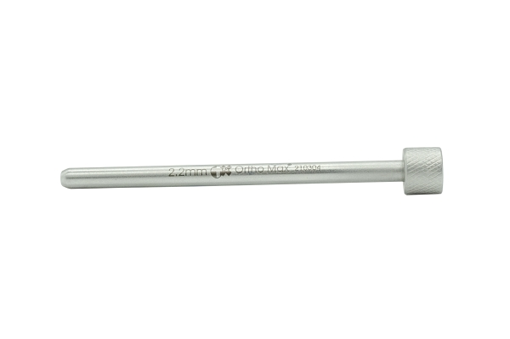
Function
The sleeve is a thin stainless steel tube with a 2.2 mm internal channel and a sharp tip for tissue penetration. It is inserted through the skin to the bone surface before the drill bit is passed through its inner channel. The sleeve holds the drill bit perpendicular to the bone surface, guides the drill through both cortices, and prevents soft tissue from wrapping around the rotating bit and being dragged into the drill hole.
Advantages
Prevents Soft-Tissue Wrapping on Drill Bit: The sleeve isolates the rotating drill bit from surrounding muscle and fascia, preventing the serious soft-tissue injuries and drill bit entanglement that occur when unprotected bits are used percutaneously in the heavily muscled thigh and brachium.
Accurate 2.2 mm Drill Guidance for Small Implants: The tight 2.2 mm inner channel ensures the drill bit cannot wander from the planned interlocking hole trajectory, producing an accurately placed drill channel that matches the 2.2 mm interlocking screw diameter used in small veterinary intramedullary nail systems.
FAQ
Q: What screw size uses a 2.2 mm drill sleeve in veterinary intramedullary nailing?
A: The 2.2 mm drill sleeve guides the pilot drill for 2.7 mm interlocking screws used in small veterinary intramedullary nail systems for cats and small-breed dogs.
Q: Is the 2.2 mm sleeve used with both cortices for interlocking screws?
A: Yes. The sleeve length is designed to guide the drill through both the near and far cortex in a single insertion, ensuring accurate bicortical interlocking screw hole placement.

ORTHOPAEDIC INSTRUMENTS
Instruments for Intramedullary Nails
Drill Sleeve 2.7mm
Intended Use
The 2.7 mm drill sleeve is a tissue-protecting drill guide used in veterinary orthopaedic surgery to guide a 2.7 mm drill bit through soft tissue to bone during intramedullary nail interlocking screw hole preparation in medium-breed dogs. It ensures accurate, safe percutaneous drilling for cortical interlocking screw fixation. | 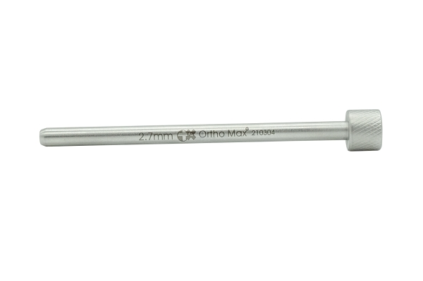
Function
The sleeve tube has a 2.7 mm internal channel sized for the corresponding drill bit and sharp cortical-contact tip. After percutaneous insertion to the bone, the drill is passed through the sleeve channel and drills the interlocking hole through both cortices under sleeve guidance. The sleeve prevents soft-tissue entanglement, maintains drill perpendicularity and protects the surgeon from glove puncture by the rotating drill tip.
Advantages
Accurate Guidance for 2.7 mm Interlocking Holes: The 2.7 mm inner channel maintains precise drill trajectory for the interlocking screw holes in medium veterinary intramedullary nail systems, preventing angulated holes that would result in poor screw-nail engagement and construct instability.
Protects Surgeon and Patient During Percutaneous Drilling: The sleeve prevents both patient soft-tissue injury from unguided drill bits and surgeon glove puncture injury during percutaneous interlocking hole drilling, improving safety in the surgical team during intramedullary nail fixation.
FAQ
Q: What interlocking screw size corresponds to the 2.7 mm drill sleeve?
A: The 2.7 mm sleeve guides the pilot drill for 3.5 mm cortical interlocking screws used in standard medium veterinary intramedullary nail systems for dogs in the 10–30 kg range.
Q: Can drill sleeves be reused after sterilisation?
A: Stainless steel drill sleeves are designed for reuse and can be autoclaved; the inner channel should be inspected for drill debris before each sterilisation to ensure clean guidance for the next use.

ORTHOPAEDIC INSTRUMENTS
Instruments for Intramedullary Nails
Intramedullary Reamer for Femur - Solid
Intended Use
The solid intramedullary femoral reamer is a canal-enlarging instrument used in veterinary orthopaedic surgery to progressively enlarge the medullary canal of the canine femur before intramedullary nail insertion. Reaming allows a larger-diameter nail to be placed, increasing construct stiffness and torsional stability during fracture fixation in dogs. | 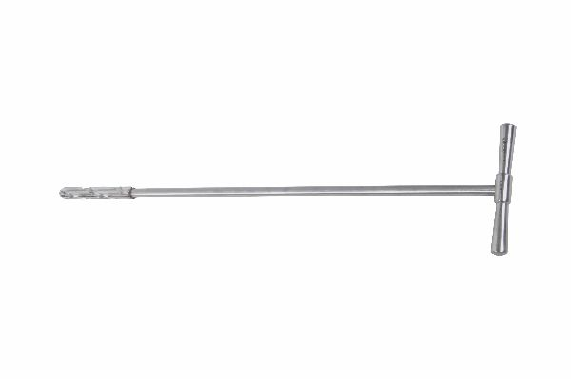
Function
The solid reamer has a fluted cutting head attached to a rigid shaft connected to a hand chuck or power drill. Rotating the reamer within the medullary canal removes cancellous and endosteal bone chips, progressively widening the canal diameter. Sequential reaming with increasing head diameters enlarges the canal to 1 mm greater than the planned nail diameter, enabling tight nail-to-canal fit without eccentric loading.
Advantages
Increased Nail Diameter for Greater Stiffness: Reaming to accommodate a larger-diameter nail substantially increases construct bending and torsional stiffness — the fourth power of nail radius determines bending stiffness — improving fracture stability and reducing nail fatigue failure risk in active large-breed dogs.
Improved Nail-to-Canal Contact: Reaming creates a smooth, round medullary canal interior that maximises circumferential contact between the nail and endosteal bone, reducing nail migration and improving rotational resistance beyond that achievable with non-reamed canal insertion.
FAQ
Q: What diameter does the femoral canal need to be reamed to?
A: The canal should be reamed to 1 mm greater than the planned nail outer diameter, allowing controlled nail impaction to final seated position without excessive cortical stress during insertion.
Q: Is intramedullary reaming always necessary for canine femoral nailing?
A: Reaming is recommended when the nail diameter is within 1–2 mm of the canal isthmus diameter. Nails significantly smaller than the canal can be inserted without reaming but provide reduced rotational stability.

ORTHOPAEDIC INSTRUMENTS
Instruments for Intramedullary Nails
Nail Holding Bolt
Intended Use
The nail holding bolt is a temporary fixation component used in veterinary orthopaedic surgery to secure an intramedullary nail to the insertion jig or targeting device during nail impaction and interlocking screw insertion in dogs and cats. It prevents nail rotation relative to the targeting device during the interlocking step. | 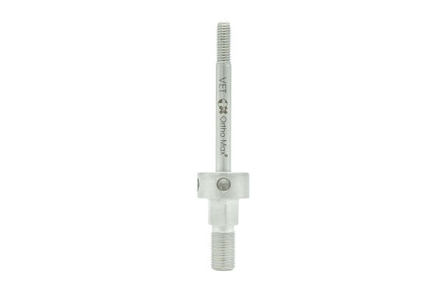
Function
The bolt threads into a dedicated hole at the proximal end of the intramedullary nail, coupling the nail rigidly to the insertion handle or targeting jig. This rigid connection transmits the orientation of the jig's interlocking hole guides directly to the nail's interlocking holes within the bone, ensuring the drill trajectories from the jig align accurately with the nail holes for interlocking screw insertion.
Advantages
Maintains Nail-to-Jig Alignment During Interlocking: Rigid bolt coupling prevents any rotation between nail and targeting jig after final nail seating, ensuring all subsequent interlocking screw drill trajectories are aligned with the nail hole positions within the medullary canal.
Allows Rotational Adjustment Before Final Locking: Before tightening the nail holding bolt, the nail can be rotated within the canal to achieve the correct rotational alignment of the fracture fragments; bolt tightening then locks this optimal position for interlocking.
FAQ
Q: Is the nail holding bolt removed after interlocking screw insertion?
A: Yes. The nail holding bolt is a temporary instrument component removed along with the insertion handle after all interlocking screws are placed; it is not part of the implanted intramedullary nail construct.
Q: What thread size does the nail holding bolt use?
A: Thread size varies by nail system manufacturer; the bolt must match the thread in the proximal nail end exactly — using a mismatched bolt can damage the nail thread and compromise the targeting jig coupling.

ORTHOPAEDIC INSTRUMENTS
Instruments for Intramedullary Nails
Protection Sleeve
Intended Use
The protection sleeve is a tissue-shielding guide tube used in veterinary orthopaedic surgery during intramedullary nail interlocking screw insertion to protect soft tissues from the rotating drill bit and trocar during percutaneous drilling and screw insertion in dogs and cats. It is the outer component of the drill guide assembly. | 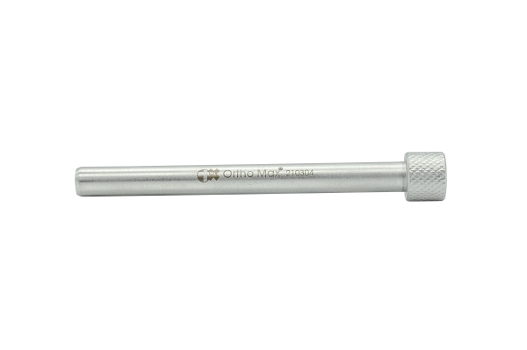
Function
The protection sleeve is a wide-bore outer tube inserted through the skin incision to the bone surface. The smaller drill sleeve is placed inside the protection sleeve to guide the drill bit. The protection sleeve's larger outer diameter prevents skin and subcutaneous tissue from prolapsing into the drill path during bit rotation, while the inner drill sleeve maintains precise drill trajectory to the interlocking hole position.
Advantages
Two-Layer Tissue and Drill Protection: The protection sleeve and inner drill sleeve together provide a two-layer protective system — the protection sleeve guards broad soft-tissue areas and the inner sleeve precisely guides the drill — offering superior tissue safety compared with a single-tube system.
Prevents Skin Edge Damage During Screw Insertion: The protection sleeve holds the skin portal open and protects the skin edges from abrasion and tearing during the screwdriver insertion step that follows drilling, reducing wound dehiscence at percutaneous interlocking screw sites.
FAQ
Q: How does the protection sleeve differ from the drill sleeve?
A: The protection sleeve is the larger outer tube that protects broad soft-tissue areas; the drill sleeve is the smaller inner tube that precisely guides the drill bit. The protection sleeve is placed first and the drill sleeve inserted through it.
Q: Is a protection sleeve used for both proximal and distal interlocking screws?
A: Yes. Protection sleeves are used for all percutaneous interlocking screw insertions regardless of their position along the nail, as soft-tissue wrapping risk from unguided drilling is present at every interlocking site.

ORTHOPAEDIC INSTRUMENTS
Instruments for Intramedullary Nails
Rush Nail Impactor - Bender
Intended Use
The Rush nail impactor-bender is a dual-function instrument used in veterinary orthopaedic surgery to bend Rush pins to the required curvature and subsequently drive them into the medullary canal of long bones in dogs and cats during intramedullary fracture fixation. It combines pre-insertion bending and canal impaction in one instrument. | 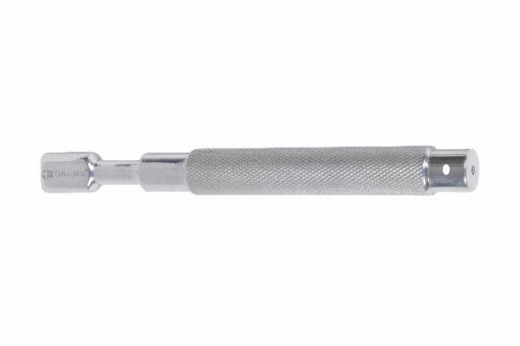
Function
The bending function uses a fulcrum pin and handle leverage to create a controlled curve in the Rush nail before insertion. The impactor function uses the handle as a striking surface for mallet impaction, transmitting axial force through the instrument to the nail end during canal insertion. The combination allows the surgeon to perform both preparatory bending and intramedullary driving without changing instruments.
Advantages
Bending and Impaction in One Instrument: Combining pre-insertion bending and canal driving in a single instrument eliminates the need for a separate roller bender and impactor, reducing instrument count, setup time and the risk of dropped instruments during the procedure.
Controlled Curvature for Three-Point Fixation: The fulcrum bending mechanism applies a reproducible, calibrated curve to the Rush pin, enabling consistent three-point endosteal canal contact that is the mechanistic basis of Rush pin rotational stability.
FAQ
Q: What is a Rush pin and how does it differ from an Ender nail?
A: Rush pins are smooth, prebent spring-steel pins with a hooked tip that engages the far cortex; Ender nails are similarly flexible but straighter with a blunt end. Both provide three-point medullary fixation but with different tip engagement mechanisms.
Q: What fractures are best suited to Rush pin fixation in veterinary patients?
A: Rush pins are most effective for metaphyseal and diaphyseal fractures of the radius, ulna, tibia and femur in small to medium-breed dogs and cats where the medullary canal diameter accommodates two or more pins.

ORTHOPAEDIC INSTRUMENTS
Instruments for Intramedullary Nails
Square Nail Punch
Intended Use
The square nail punch is a driving instrument used in veterinary orthopaedic surgery to impact square-section intramedullary nails into the medullary canals of long bones in dogs and cats during fracture fixation. Its square socket engages the proximal nail end to transmit mallet force without rotating or slipping on the flat nail surface. | 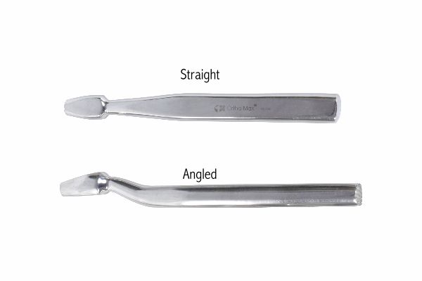
Function
The punch has a distal square socket that fits precisely over the proximal square end of the intramedullary nail. The proximal striking face accepts mallet blows. The square socket-to-nail engagement transmits impact force axially into the nail without the rotational slippage that would occur with a round punch on a square nail — enabling efficient, controlled nail advancement into the medullary canal.
Advantages
Anti-Rotation Square Engagement: The square socket geometry prevents punch rotation on the nail end during impaction, ensuring all mallet force is transmitted as axial driving energy rather than being lost to rotational slippage on the nail surface.
Protects Proximal Nail End Geometry: The deep socket fully covers the proximal nail end, distributing mallet impact force over the full nail cross-section and preventing peening or deformation of the nail end that would complicate future nail extraction.
FAQ
Q: What nail sizes are square nail punches available for?
A: Square nail punches are available in socket sizes matching the standard square nail cross-sections used in veterinary surgery — typically 3×3 mm, 4×4 mm and 5×5 mm — and must be matched to the specific nail being used.
Q: Can a square nail punch be used for round intramedullary nails?
A: No. Square socket punches will not engage round nail ends; a separate impactor with a round socket or flat striking face is required for round-section intramedullary nails and pins.

ORTHOPAEDIC INSTRUMENTS
Instruments for Intramedullary Nails
Square Nail Reamers
Intended Use
Square nail reamers are canal-shaping instruments used in veterinary orthopaedic surgery to convert the circular medullary canal cross-section into a square or rectangular profile before square intramedullary nail insertion in dogs and cats. Matching the canal shape to the nail cross-section prevents nail rotation within the canal during fracture fixation. | 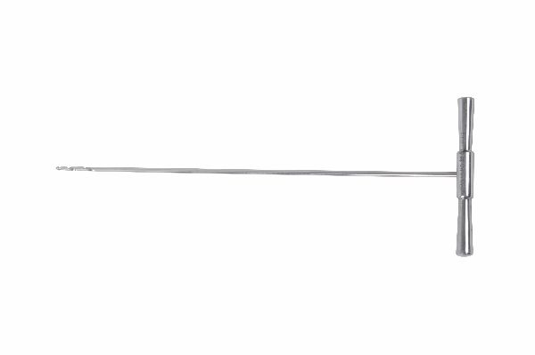
Function
The reamer has a square or rectangular cutting head with hardened cutting edges on each face. Rotating the reamer within the previously drilled circular canal progressively removes bone from the canal walls, converting the circular profile to a square cross-section. The reamer is advanced in progressive steps matching nail length until the full nail insertion path is profiled to the correct square shape.
Advantages
Canal-to-Nail Shape Matching Eliminates Rotation: Converting the canal to a square cross-section creates mechanical interlocking between the four nail faces and the four canal walls, providing inherent anti-rotation resistance without requiring interlocking screws in simple fracture configurations.
Progressive Material Removal Protects Cortex: The stepped sequential reaming protocol removes small amounts of bone per pass, preventing the large thermal and mechanical stresses generated by attempting to create the full square profile in a single reaming stroke through hard cortical bone.
FAQ
Q: Are square intramedullary nails commonly used in veterinary orthopaedics?
A: Square nails are used in selected veterinary practices for femoral and tibial fractures in medium-breed dogs where their anti-rotation properties are preferred over round nails that require interlocking screws for rotational control.
Q: What size sequence should be used for square nail reaming?
A: Reaming begins with a circular reamer to widen the canal isthmus, followed by the square reamer in sizes 0.5 mm smaller than the nail, then matching nail size to create the final square profile with minimal force on nail impaction.

ORTHOPAEDIC INSTRUMENTS
Instruments for Intramedullary Nails
Trocar
Intended Use
The surgical trocar is a sharp-tipped penetrating instrument used in veterinary orthopaedic surgery to create percutaneous soft-tissue portals for instrument, nail or screw insertion during minimally invasive fracture fixation and arthroscopy in dogs and cats. It enables percutaneous access to bone without open tissue dissection. | 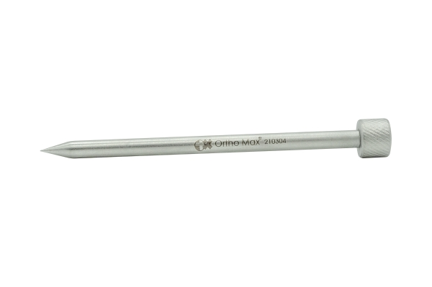
Function
The trocar consists of a sharp three-faceted pyramidal tip within an outer cannula or sleeve. The combined instrument is driven through skin and soft tissue by firm axial pressure; the sharp tip penetrates tissue while the outer cannula simultaneously dilates and maintains the portal. Withdrawing the trocar tip while leaving the cannula in situ creates a sealed portal through which instruments are passed.
Advantages
Minimally Invasive Percutaneous Access: Trocar insertion creates a working portal through skin and soft tissue without the extended incisions required for open approaches, reducing surgical trauma, postoperative pain and recovery time in veterinary fracture fixation and arthroscopic procedures.
Sealed Portal Prevents Soft-Tissue Collapse: The retained cannula holds the percutaneous portal open throughout the procedure, preventing soft-tissue collapse that would obstruct instrument passage and require repeated re-entry attempts during intramedullary nail interlocking and arthroscopic procedures.
FAQ
Q: What is the difference between a trocar and a bone awl?
A: A bone awl penetrates cortical bone to create the medullary entry portal; a trocar creates a soft-tissue portal through skin and muscle to provide access to the bone surface. Trocars are used for percutaneous soft-tissue access, not bone penetration.
Q: Are trocars reusable in veterinary surgery?
A: Stainless steel trocars are designed for reuse after proper cleaning and autoclave sterilisation; the trocar tip sharpness should be inspected before each use and the instrument replaced if tip dulling or damage is found.

ORTHOPAEDIC INSTRUMENTS
Instruments for Intramedullary Nails
Vet Jig
Intended Use
The veterinary intramedullary nail targeting jig (vet jig) is a precision alignment instrument used in veterinary orthopaedic surgery to guide interlocking screw drill holes accurately to the interlocking hole positions within an intramedullary nail during fracture fixation in dogs and cats. It eliminates the need for fluoroscopic interlocking guidance. | 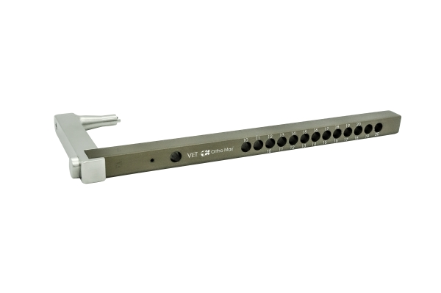
Function
The jig attaches rigidly to the proximal end of the intramedullary nail via the nail holding bolt before nail insertion. The jig arms project outward from the nail axis and carry drill guide holes that are positioned and angled to correspond exactly to the interlocking hole positions in the nail shaft. After nail seating, the drill is passed through the jig guide holes, through bone, and through the nail interlocking holes without intraoperative X-ray guidance.
Advantages
Fluoroscopy-Free Interlocking Screw Insertion: The vet jig eliminates the need for intraoperative fluoroscopy during interlocking screw placement, reducing radiation exposure to the surgical team, shortening procedure time, and lowering the equipment requirements for intramedullary nail fixation in veterinary practices.
Multiple Interlocking Hole Guidance in One Setup: The jig simultaneously guides both proximal and distal interlocking drill holes in a single attachment, allowing all interlocking screws to be placed without removing and reattaching the targeting device between each screw.
FAQ
Q: Does the vet jig work for all sizes of intramedullary nails?
A: Each vet jig is designed for a specific nail system and size; the jig arm length and guide hole positions must exactly match the interlocking hole locations in the nail being used. Manufacturer-specific jigs should not be interchanged between different nail systems.
Q: What happens if the nail rotates slightly after jig attachment and before interlocking?
A: Any nail rotation after jig attachment misaligns the jig guide holes from the nail interlocking holes, causing missed interlocking attempts. The nail must be repositioned and the jig realigned before drilling.

